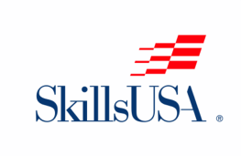SkillsUSA Membership Form
Dorchester Career and Technology Center
2018-2019

Student _____________________________________________________________________
Address _____________________________________________________________________
City __________________________ State ___________________ Zip Code ______________
DCTC Class ________________________________________ Birthday ______________
Graduation Date: ___________________________
SkillsUSA is a National Organization for students enrolled in a Career and Technology Course.
Membership dues are $20.00.

___________________________________________________________________________
Student Signature Date

If you have any questions please contact me at 410-901-6950 or email zinnelc@dcpsmd.org
Chef Zinnel
SkillsUSA Advisor
Culinary Arts Instructor

SkillsUSA Fact Sheet

What is SkillsUSA?

- A national nonprofit student organization serving more than 300,000 students enrolled in Career & Technical Training Programs at public high schools and colleges.

- As of last year (SkillsUSA) was considered to be one of the largest student run organizations in the country.

What do students gain from SkillUSA participation?

- A chance to learn and practice employment skills and leadership skills that will result in greater confidence.

- Opportunities to complete in the SkillsUSA Championships at the local, regional, state, and national levels.

- Opportunities for local, state or national scholarships and honors.

- Job contacts and networking opportunities within the industry.

- Recognition from peers, teachers and community leaders.

- Opportunities to attend state or national leadership conferences.

- Access to SkillsUSA employment resources with over 1100 business, industry and labor sponsors.

8. Chances to travel, meet new people and develop meaningful friendships.

